

Tel-Aviv University

Google Technologies for Cloud

and Web Development

March 2014

**Developed by:**

Ofir Ventura

Shir Lev

Tomer Filiba

Yana Tartakovsky

Table of Contents

Introduction 3

Architecture Overview 4

Main APIs 5

Product Overview 6

User Manual 7

First Time User 7

Creating New Event 8

My Events Page 9

Invited To Page 10

Calendar Voting Screen 11

Calendar Page Options: 12

Event Owner Extra Options: 13

Introduction

Modern everyday life has become very busy and hectic, thus planning any kind of event with several participants could be quite difficult. Thus whenever there is a social event/business meeting/family dinner, trying to find the time that is comfortable for all the participants is nearly impossible.

Here is where Sched’Up comes in the picture. Sched’Up is a web application developed as a final project in Google workshop at Tel-Aviv University. It is an application made to optimize the process of scheduling an event.

Instead of having long discussions about it, and being unable to comfortably sync with everyone, one can use Sched’Up.

With Sched’Up, you can stop worrying about finding the time for the event so that all your guests would be comfortable.

Simply open an event and then select the time window in which you want to have the event (i.e. next two weeks, this weekend etc.). Now all your guests can choose their preferred times, and you can quickly decide on the date. When an event is finalized, it is sent to all your guests and added to their calendar

Sched’Up provides the possibility to connect either to your Google or to your Facebook account. Once logged-in you can find your guests using your address book or friends list. You can also see your schedule for the desired window.

Sched’Up can be found at: <http://sched-up.appspot.com>

And at Google Play for Android users (requires version 2.2 and up): <https://play.google.com/store/apps/details?id=com.appspot.schedup>

Contact us at: <https://www.facebook.com/schedupapp>

Architecture Overview

Main APIs

* **JQuery Mobile:** Framework used as a basis for our application. JQM is written in HTML, css and JavaScript. We used this framework to accomplish mobile compatibility and simplify the client-side scripting of HTML.
* **Django:** High level python web framework that helps make a clean design and rapid development.
* **Google Accounts API:** Connecting the user to his Google account. The purpose of this is to sync the calendar voting page with the user’s calendar and loading the user’s contacts.
* **Google Calendar API:** Creating events and managing them (i.e sending invites, updating event etc.).
* **Google Datastore:** Server side database.
* **Google Places:** Helps the user by auto-completing the event location and suggesting places.
* **Facebook API:** Connecting the user to his Facebook account. This gives us the ability to access the user’s Facebook contacts, syncing with Facebook events, creating Facebook events and inviting friends to vote in the application and to the final event via Facebook.
* **GCM:** Google Cloud Messaging. Used to send notifications to our native Android application.
* **Font Awesome:** An API providing fonts and icons that were used to improve the appearance of the application.
* **Owl Carousel:** A visual carousel of images. Used in the home page to demonstrate new users how to use the application.

Product Overview



User Manual

## First Time User

When you enter the system for the first time, you will see the Sched'Up welcome page. Here you can log in via Google or Facebook account.

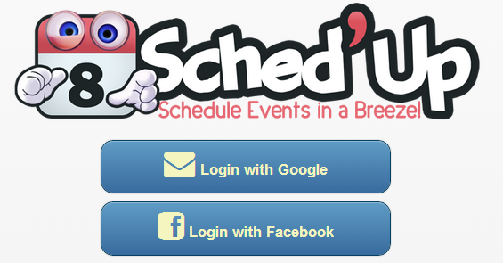

At the bottom of this page you can also find a tutorial which presents the app's main usage and gives a quick briefing over the steps in creating an event.

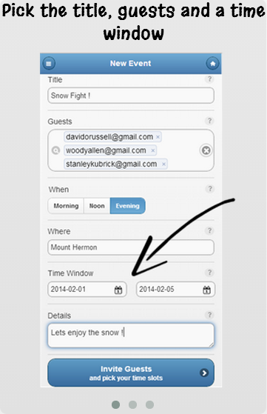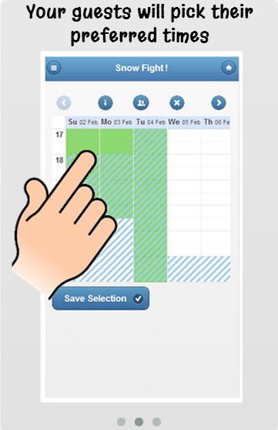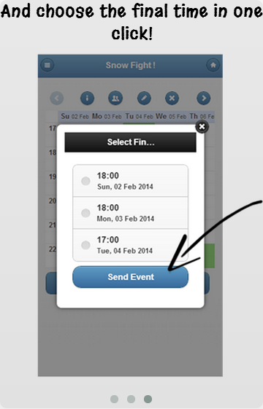

After signing in, the user will be transferred to "My Events" page. Registered users can always go back to this page by clicking "Help" on the sidebar menu.

## Creating New Event

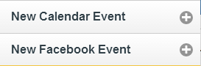In order to create a new event, click on one of the following in the side-bar menu.

Both options will direct you to the next form:

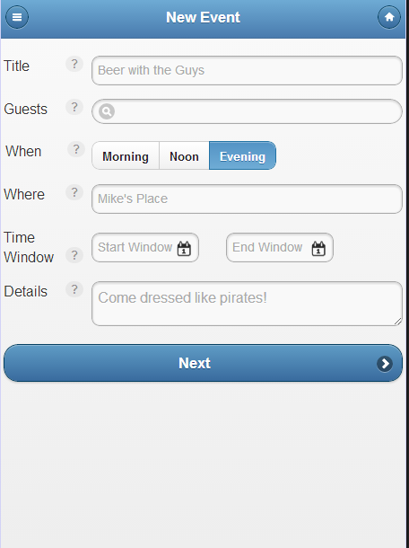

**Title:** for the event. This field is required.

**Guest** **list**: You must enter at least one guest. The autocomplete from your Google contacts or from your Facebook friends – depends on the kind of event you choose to create.

**When**: multiple choice button. describes the range of hours for your event. The calendar view in the Calendar Voting Screen will be according to this choice.

**Where:** the event will take place. Optional field. Autocomplete from Google Places.

**Time Window:** of the event. Defined by "Start Window" and "End Window" which are required fields. Your guests will choose convenient time slots in this window.

**Details**: optional field. You can use it for any purpose you want: set a dress code, describe your event, etc.

After filling all necessary fields click "Next" and you'll be transferred to the Calendar Voting Screen to submit your preferred time and send invitations.

## My Events Page

This is the homepage for registered users. Here you can see a list of all the events you've created, and some information that will help you manage them.

Every event displays the title, time-window and notifications.

The notifications let you know how many actions (such as declining, voting for preferred times etc.) your guests performed.

The list is ordered by the ending date of the time window, which will encourage you to handle more urgent/relevant events first.

An event will be removed from the list if canceled, three days later than the date applies, or three days later than the end of his time window if no date was set final.

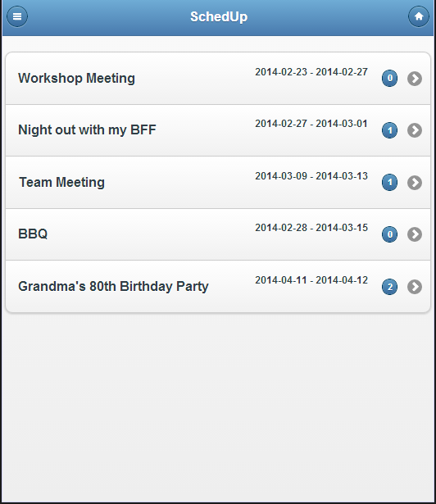

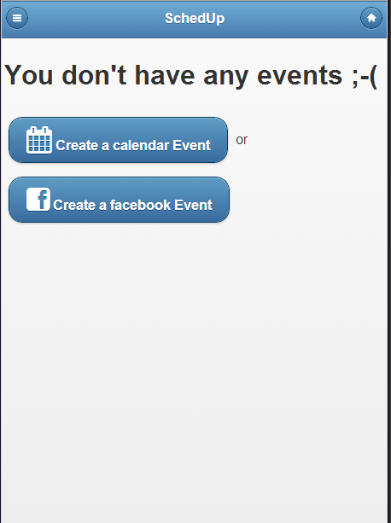

## Invited To Page

Similarly to the My Events Page, this page displays events to which you are invited. An event can be colored in one of 3 colors by your response status.

Events you've already submitted your preferred time slots – colored in grey.

Events you've declined – colored in black.

Events that are waiting for your vote – colored in yellow.

You can also track how many events are waiting for your vote ("yellow events") through the notifications bubble on the "Invited To" button in the side-bar menu.

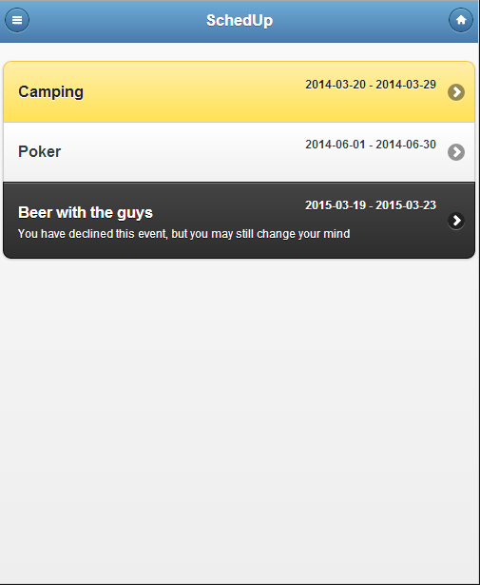

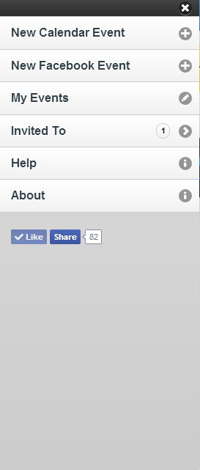

In both "My Events" & "Invited To" pages you can always click on the event for more information or for changing your votes, which will direct you to the Calendar Voting Screen.

## Calendar Voting Screen

In the Calendar Voting screen, you will be able to pick your preferred times for the event, whether you own the event or invite others to it.. You will also be able to see others` votes, your calendar and your Facebook events, to help you make the best decision.

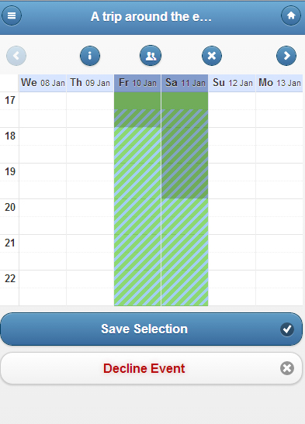

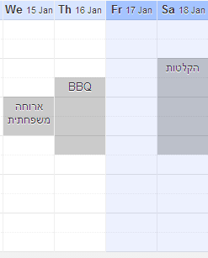This is how your Calendar and Facebook events will look like:

### Calendar Page Options:

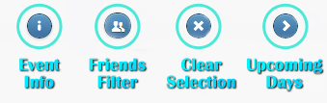As a guest, these are the main features you will have in the voting screen:

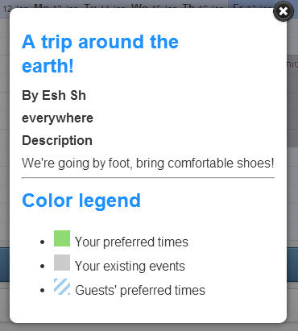 ** Event Info:**

Under this option, you will be able to see the event info: Description, who created the event, what to bring.

Also, there is a color legend, which explains the different colors on the voting screen, as follows in the next figure.

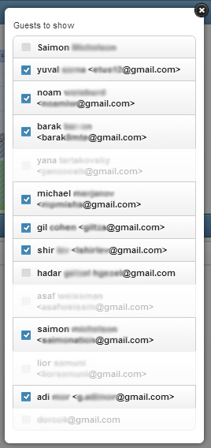

 **Friends Filter: **

Under this option you will see the guests list, and get all the information regarding the event: Who was invited, who voted, who declined and who has not yet responded.

Unchecking one of the guests will turn his\her votes invisible on the calendar voting page. Checking the name back will show his\her votes again.

 **Clear Selection:**

This option clears your own votes.

 **Next (and Back):**

These arrows let you move back and forth on the visual calendar. It will be available if the time window that was chosen is bigger than the screen width.

### Event Owner Extra Options:

**Edit event:**

Editing the event will be available to the event owner only. Under this option you can edit all the fields that were on the “New Event” page. Your guests will be notified to any change that you will do.

**Save and Send Invites:**

This option will also be available to the event owner only. After choosing your preferred times for yourself as an event owner, you can save your selection and send the invites to your guests. If the event is a calendar event, your guests will receive an email notifying them of the event. If the event is a Facebook event, they will receive the event on their Facebook page as a Facebook event with a direct link to the voting page.

**The email message looks as follows:**

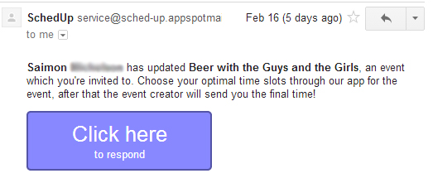

**The Facebook invites looks as follows:**

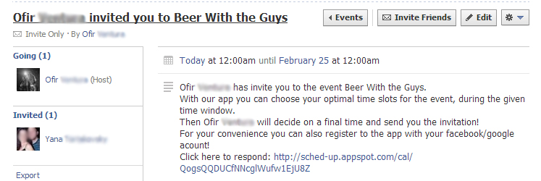

After the invites were sent to the guests, you will have those options as an event owner:

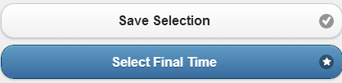

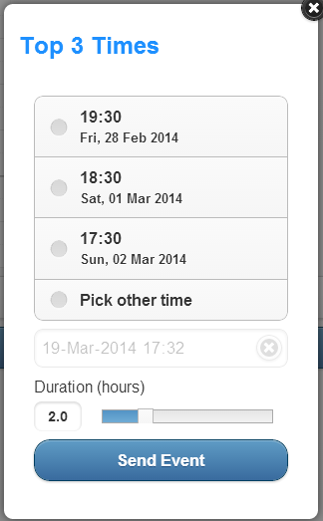 You will be able to change your own votes the whole voting time, and also choose when you want to close the votes and pick the final time to your event.

When clicking on “Select Final Time”, we suggest you the best times for your events, based on your votes and your guests’ votes.

After choosing the best time, you will select the duration of the event. If it is a calendar event, it will be shown on the final calendar event that will be sent to the guests. If it is a Facebook event, it will be shown on the final Facebook event.

**“Send Event”** will send the final event based on the “Event Info” (Description, Guests etc.) and the final time.